**SMARTBRIDGE IN COLLABORATION WITH IBM**



**A PROJECT ON**

**PREDICTING LIFE EXPECTANCY USING MACHINE LEARNING**

SUBMITTED IN FULFILMENT FOR THE COMPLETION OF

THE PROJECT

AT

SMARTBRIDGE

Submitted by

SUNKARA CHANDANA

**ABSTRACT**

Life expectancy is a statistical measure of the average time a human being is expected to live. Life expectancy depends on various factors including: financial status, regional variations, economic circumstances, gender differences, mental illnesses, physical illnesses, education, year of their birth, demographic factors and many more.

In this project we collect historical data regarding the GDP, year, development status, education, alcohol intake of people in the country, expenditure on healthcare system and some specific disease related deaths that happened in the country and utilize this data to develop a Machine Learning model which is then used to predict the life expectancy.

This project is aimed at predicting Life Expectancy rate of a country, given various factors, using Machine Learning algorithms.

**LITERATURE SURVEY**

**EXISTING PROBLEM**:

Life Expectancy rate is the average time a human being lives. This is based on various health, education and economic factors. If life expectancy rate is low, the time s person lives is less, which is not desired.

**PROPOSED SOLUTION**

This project develops a Regression Machine Learning model which makes use of historical data to train and develop the model. This model is then used to predict the average life expectancy of people living in a country provided, given conditions. Through this we can get to know the various factors affecting life expectancy and the ranges or values the factors must have to get a desired life expectancy.

**THEORETICAL ANALYSIS**

**BLOCK DIAGRAM**



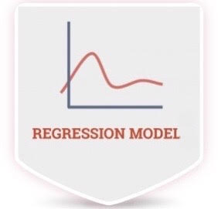    

Regression Model IBM Watson Studio Node-RED User Interface





**DESIGNING THE PROJECT**

A typical Regression Machine Learning project leverages historical data to predict insights into the future. This problem statement is aimed at predicting average life expectancy of people living in a country given various features.

Firstly, the required data set is collected from <https://www.kaggle.com/kumarajarshi/life-expectancy-who> . Secondly, an IBM Watson studio project is created in the Watson Studio service, provided by IBM Cloud. Then, the data set is imported into this project and latter an AutoAI experiment is performed. The best algorithm of the many algorithms run during the AutoAI experiment is saved as a model. This model can be opened in the Watson Studio project and tested giving the inputs.

A User Interface (UI) is designed for the project using Node-RED. In this User Interface the users can type in data regarding their country’s gdp, alcohol intake, diseased count, deaths count, income and expenditure, education level, etc. and get the output which is the predicted life expectancy of the country.

**OUTPUT SCREENSHOTS**

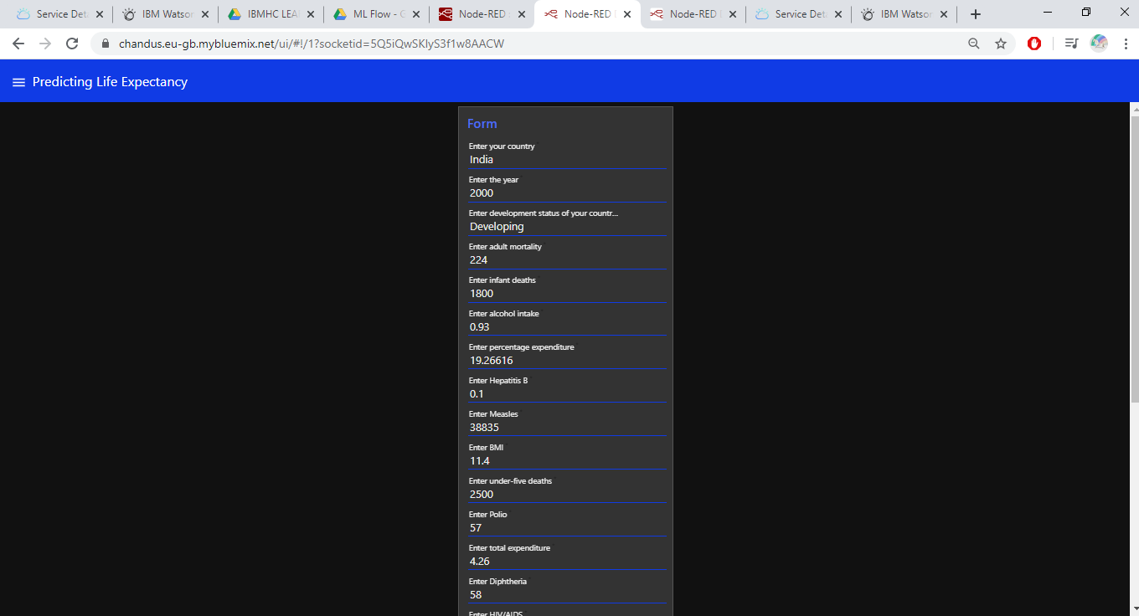

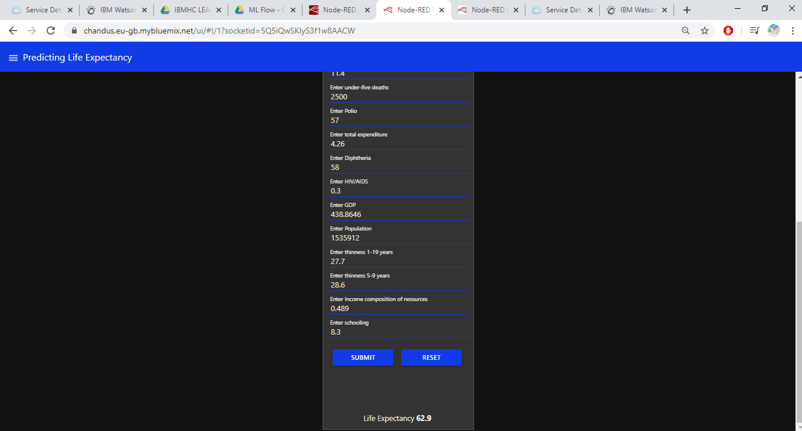

**FUTURE SCOPE**

This project tells the average age a person of a country is expected to live. This provides insights in various factors and their levels required to keep the life expectancy rate as high as expected.

**BIBILOGRAPHY**

<https://smartinternz.com>

<https://www.kaggle.com/kumarajarshi/life-expectancy-who>